The client we are working for is Rexburg City’s Wastewater treatment plant. The City of Rexburg’s Wastewater treatment plant currently doesn’t have a smooth operation of reporting plant flow, ammonia levels, USGS (United States Geological Survey), and other types of chemicals. The plant has an excel file that I have fixed to correctly change dates accept inputs to output weekly and monthly averages. The excel file has about 5 different sheets that reference each other. For my senior project I have created a Shiny application that makes use of the USGS’s API to grab the monthly river flow rate from historical dates to current. This app will allow you to select dates and outputs an interactive graph and a data table with the weekly and month average. You are able to download the graph and data table for a report, you are also able to download the raw data if you wanted it. The downloadable data table below the graph highlights the cell red if the weekly and/or the monthly average is below 81.

Below is what the downloadable report looks like.

DMR Report

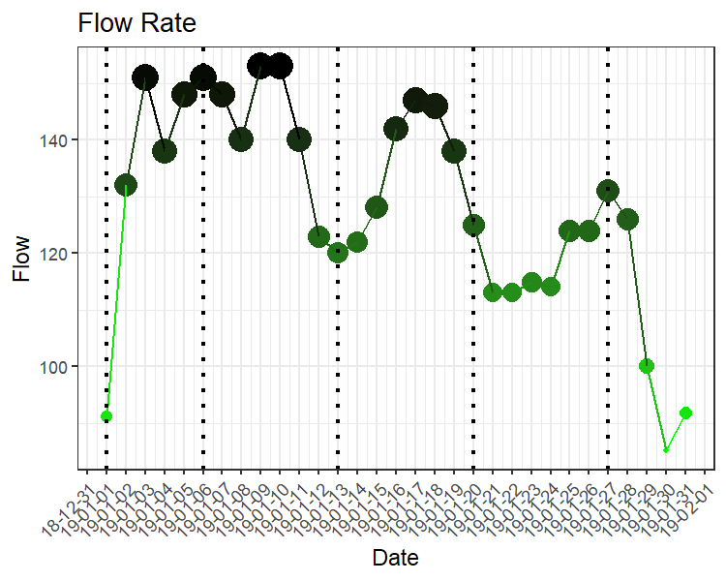

|  |  |  |  |  |
| --- | --- | --- | --- | --- |
| Week Number | mean | max | min | Count |
| 1 | 132.0 | 151 | 91.1 | 5 |
| 2 | 144.0 | 153 | 123.0 | 7 |
| 3 | 134.7 | 147 | 120.0 | 7 |
| 4 | 118.3 | 125 | 113.0 | 7 |
| 5 | 106.8 | 131 | 85.2 | 5 |
| JanuaryAverage | 128.2 | 153 | 85.2 | 31 |

The client would like this report to export to an excel file in their desired format (exporting this to a excel file isn’t going to be hard, right now I have it exporting to a word file.)

I have a couple different files in my repository, the main two that I worked with were

* DMR_app
* Pulling_data

**DMR_app**

* This is the file where the app is built, I have notes inside of the script as to what each piece of code is doing.

**Pulling_data:**

* I called this script my playground because this is where I created and tested all of my code.
* This script doesn’t have as good of notes in it, I need to go back and add better notes so its easier to follow what I was doing
* At the bottom of the script I was trying to use the package rnoaa, this is a package where you can download weather data. I wanted to use weather data along with the flow data (that is broken into seasons) to make predictions of what flow rates for the upcoming months or even weeks would be. I was having major problems with trying to get the max and min monthly temperature to convert from Celsius to Fahrenheit, if you can figure this out then you are well on your way to making projections.
* I mentioned that the data would be broken into seasons, I have gone though and made a column with the seasons to see if there were any trends in the data.

I have created a TO-DO list/ summary with things that I have done and things that need to still be down. You can find this list below.

* Create shiny app for Rexburg City Wastewater treatment plant
  + Dates
    - Be able to have selectable dates
    - Be able to handle more than one month at a time
  + API for avg flow data
    - Website used to get the data not the API <https://waterservices.usgs.gov/nwis/dv/?format=rdb&sites=13055340&startDT=2018-04-01>
    - Be able to break into seasons for further predictions.
  + Plots
    - Plot of the average flow
    - Make plot interactive for user
    - Plotly or ggplot (the plotly is already interactive)
  + Weekly/monthly mean
    - Make a data table of the monthly/weekly flow mean
  + Data tables
    - Space for the raw data to lay in the app
    - Make a download function for just this raw data.
  + Weather data
    - Use rnoaa package (have done but cannot get to work)
    - Get API token to obtain data
    - Get season precipitation, max and min temperature.
  + Predictions
    - Make predictive model of average flow data
    - Include weather data
  + Download button
    - Be able to download tables, and plots for a report.
  + Reports
    - Have a report that exports to a excel file in their desired format.
* Post app on shiny server for client to view
* For further use
  + Create drop downs for other counties in Idaho
    - Be able to handle other counties in Idaho

Jared Gunderson Foreman of the wastewater treatment plant. 208-716-1323